**PRACTICE QUESTION PAPER (23/06/2025)**

**Section A: Basic Try-Except (2 marks each)**

**1. Divide two numbers, handle ZeroDivisionError**

try:

a = int(input("Enter numerator: "))

b = int(input("Enter denominator: "))

result = a / b

print("Result:", result)

except ZeroDivisionError:

print("Error: Cannot divide by zero.")

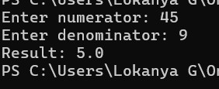

**2. Convert string to integer, handle ValueError**

try:

num = int(input("Enter a number: "))

print("You entered:", num)

except ValueError:

print("Error: Invalid input. Please enter a valid integer.")

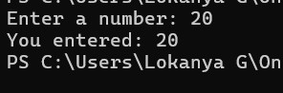

**3. Add two numbers, handle invalid input**

try:

a = float(input("Enter first number: "))

b = float(input("Enter second number: "))

print("Sum:", a + b)

except ValueError:

print("Error: Please enter valid numbers.")

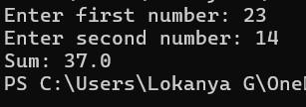

**4. Access list element by index, handle IndexError**

my_list = [10, 20, 30, 40]

try:

index = int(input("Enter index (0-3): "))

print("Element at index:", my_list[index])

except IndexError:

print("Error: Index out of range.")

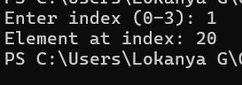

**Section B: Try-Except-Else (4 marks each)**

**5. Square of a number with ValueError**

try:

num = int(input("Enter a number: "))

except ValueError:

print("Error: Invalid input.")

else:

print("Square:", num ** 2)

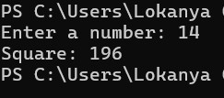

**6. Read from a file with FileNotFoundError**

try:

file = open("sample.txt", "r")

except FileNotFoundError:

print("Error: File not found.")

else:

print("File contents:\n", file.read())

file.close()

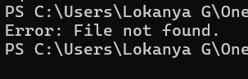

**7. Convert to binary, handle invalid input**

try:

num = int(input("Enter a number: "))

except ValueError:

print("Error: Invalid input. Please enter an integer.")

else:

print("Binary format:", bin(num))

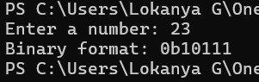

**Section C: Try-Finally (5 marks each)**

**8. Open file and ensure it is closed**

try:

file = open("sample.txt", "r")

print(file.read())

finally:

file.close()

print("File closed.")

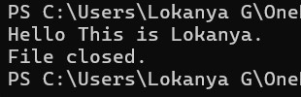

**9. Simulate login process with log message in finally**

try:

username = input("Enter username: ")

password = input("Enter password: ")

if username == "admin" and password == "1234":

print("Login successful.")

else:

print("Login failed.")

finally:

print("Login attempt logged.")

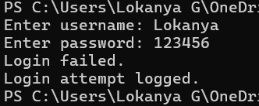

**10. Division with try-except and cleanup message**

try:

a = int(input("Enter numerator: "))

b = int(input("Enter denominator: "))

print("Result:", a / b)

except ZeroDivisionError:

print("Error: Cannot divide by zero.")

finally:

print("Cleanup: Program execution finished.")

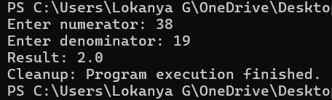

**Section D: Combined Exception Handling (6 marks each)**

**11. Handle ZeroDivisionError, ValueError, use finally**

try:

a = int(input("Enter numerator: "))

b = int(input("Enter denominator: "))

print("Result:", a / b)

except ZeroDivisionError:

print("Error: Cannot divide by zero.")

except ValueError:

print("Error: Invalid input.")

finally:

print("Execution complete.")

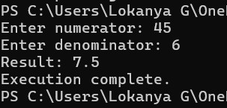

**12. Bank withdrawal with try-except-else-finally**

balance = 1000

try:

amount = float(input("Enter amount to withdraw: "))

if amount <= 0:

raise ValueError("Invalid amount.")

elif amount > balance:

print("Insufficient funds.")

else:

balance -= amount

except ValueError as ve:

print("Error:", ve)

else:

print("Withdrawal successful. Remaining balance:", balance)

finally:

print("Transaction attempt finished.")

